**A Neighbourhood Plan for Warburton**

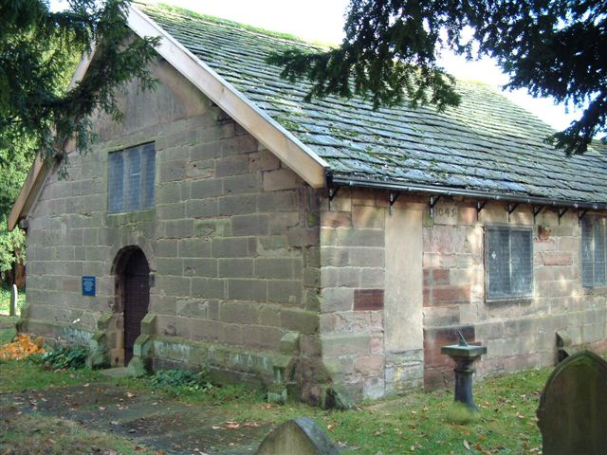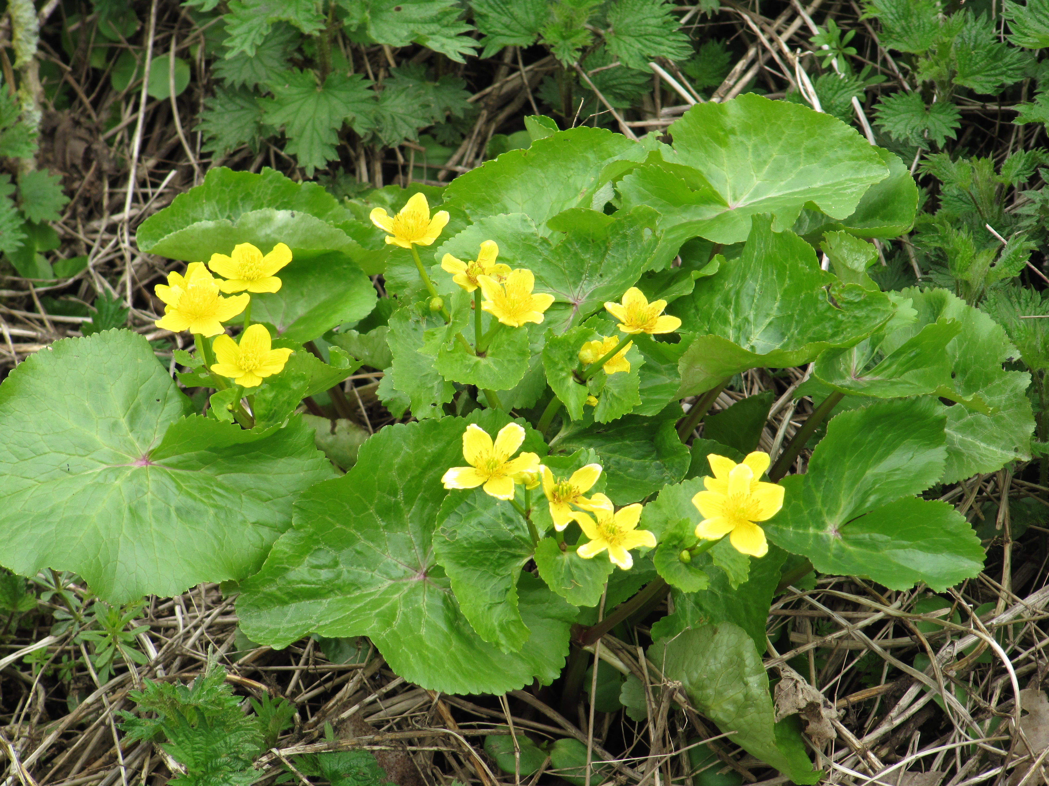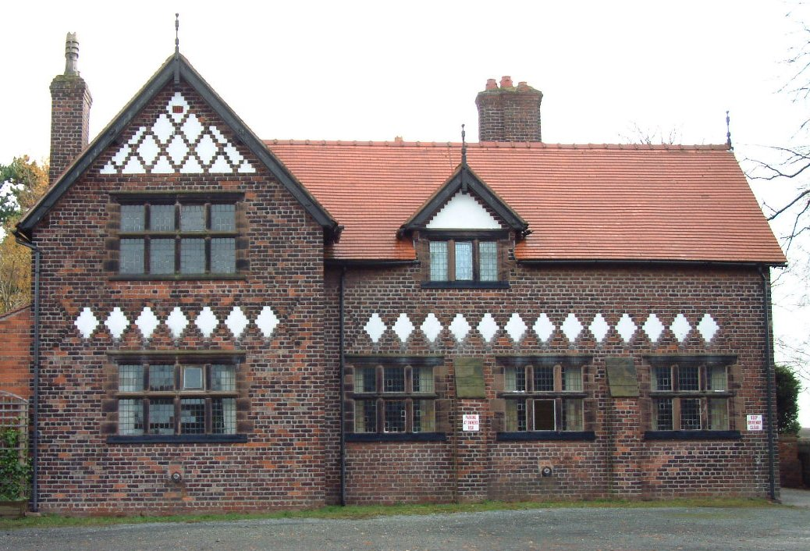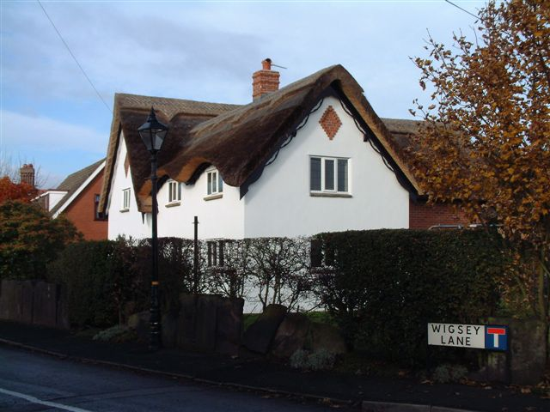

**Warburton residents are invited to attend a ‘drop-in’ session at Warburton Parish Rooms** **on Saturday December 11th from 2 p.m. to 4 p.m. Tea, coffee, wine and mince pies provided.**

In the autumn of 2018, Warburton Parish Council decided to seek permission from Trafford Council to produce a Neighbourhood Plan. On 19th May 2019 we had our launch ‘drop-in session in the Parish Rooms, but subsequently the outbreak of Covid meant we could not realistically continue. However, the Parish Council has since formed a small steering group, applied for and received grant aid, have retained Louise Kirkup from the consultants Kirkwells Planning (who specialise in assisting on the production of Neighbourhood Plans) to co-ordinate and advise on the formulation of the plan and retained the consultants AECOM to produce a Master Plan and Design Codes.

Neighbourhood planning provides a powerful set of tools for local people to ensure that they get the right types of development for their community where the ambition of the neighbourhood is aligned with the strategic needs and priorities of the wider local area.

Local communities can choose to:

* set planning policies through a neighbourhood plan that is used in [determining planning applications](https://www.gov.uk/guidance/neighbourhood-planning--2#neighbourhood-plan-relating-to-Local-Plan).
* grant planning permission through [Neighbourhood Development Orders](https://www.gov.uk/guidance/neighbourhood-planning--2#What-is-Neighbourhood-Development-Order) and Community Right to Build Orders for specific development which complies with the order.

Neighbourhood planning is not a legal requirement but a right which communities in England can choose to use.

Our unique village and its superb historic landscape setting is under threat from a number of directions. Some of these we can do little about with a Neighbourhood Plan (HS2 for example), but in others we can try to ensure that it is preserved and conserved as much as possible. Warburton Parish Council have previously produced a Village Design Statement (2004) and this will feed into the Neighbourhood Plan. The Warburton Neighbourhood Plan gives us villagers the opportunity to determine what is appropriate development and what should be protected from development for ourselves. It is a superb opportunity and one we really should not miss. Warburton Parish Council has now developed ideas for the future of Warburton village that will provide the framework for a Neighbourhood Development Plan.

This is the first phase of development of the Plan and we would like to know residents opinions and views about these ideas. This Vision Statement and Key Planning Issues document is published for informal consultation from December 1st until December 31st 2021.

We need to know whether you agree with the draft mission statement, vision and objectives and key planning themes identified so far, and whether you have any comments or suggestions for other things our Plan should address.

Please note that this Plan has specific scope and there are some important issues that affect Warburton that will not be included here. For example the impact of HS2 cannot be considered nor the future of the Toll Bridge and its effects on village residents. Equally some more everyday matters like road safety and maintenance

There are several ways in which you can provide us with your comments and ideas:

* Come along to the public drop in event at the Parish Rooms on Saturday December 11th from 2 to 4 p.m. where you can find out more and meet members of the NDP Steering Group (and get help with completing the response form) Parking is limited so please car share or make other arrangements to get there.
* Download a response form from the NDP page of the new parish Council website [www.warburtonparishcouncil.org](http://www.warburtonparishcouncil.org) (due to be launched on 1st December 2021) and email it to [Neighbourhoodplan@warburtonparishcouncil.org](mailto:Neighbourhoodplan@warburtonparishcouncil.org)
* Complete a hard copy of the response form provided at the back of the above document and return it to Warburton Parish Council, 10, Egerton Avenue, Warburton, Cheshire, WA13 9TD
* Email to Neighbourhoodplan@warburtonparishcouncil.org or send us a letter to Warburton Parish Council, 10, Egerton Avenue, Warburton, Cheshire, WA13 9TD

It doesn’t matter if you have no specialist expertise to offer, but it is important that if you have concerns about your village, have some enthusiasm to enhance and protect it and a little time that you can give, please get involved. It is critically important that the Warburton Neighbourhood Plan needs to reflect the collective opinions of the people of Warburton.

Further changes to the Neighbourhood Plan as it evolves will be shown on the Neighbourhood Plan section of the Warburton Parish Council website. We will, of course also have further drop-in sessions as the plan progresses.

Paul Beckmann

Chair of the Neighbourhood Plan Steering Group

Warburton Parish Council, November 2021